**What is Docker?**

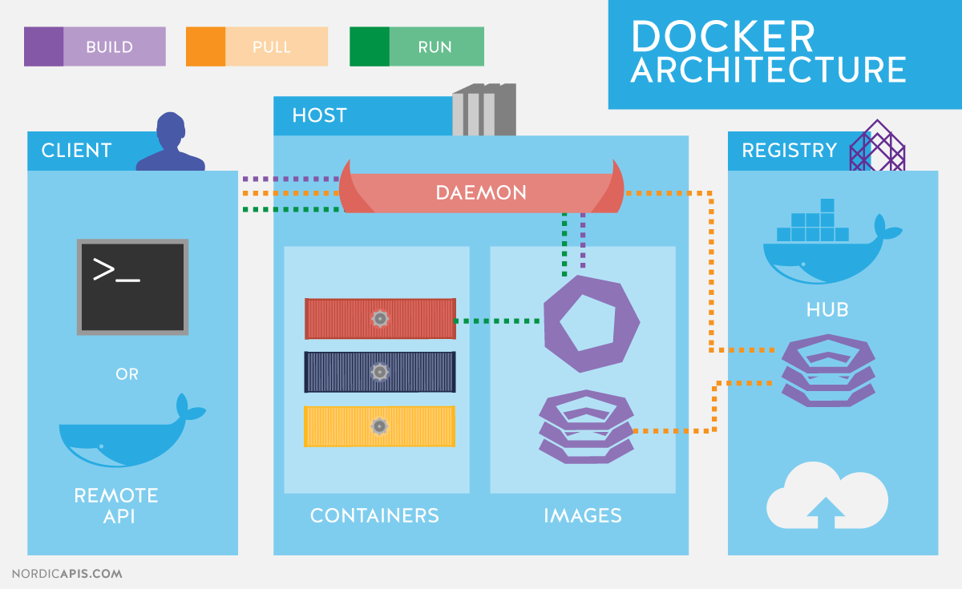

**Docker Terminology**

* **Docker Daemon**: A process that runs in the background on the Docker host, responsible for managing containers and images.
* **Docker CLI**: A command-line interface used to interact with Docker Daemon and perform container-related tasks.
* **Docker Image**: A read-only template that defines how to create a container. It contains everything needed to run an application, like the base operating system, libraries, and binaries.
* **Docker Container**: A running instance of an image. Containers are created from images and can be started, stopped, or deleted.

Docker is a platform designed to automate the deployment, scaling, and management of applications using containers. It helps package applications and their dependencies into a standardized unit, which can be easily transferred and executed on any environment. Docker simplifies the process of running an application from development to production by providing a consistent environment across different systems.

**What isn’t Docker?**

Docker is often confused with virtualization technology, but it is **not** a virtual machine (VM). Docker containers:

* **Share the host operating system (OS) kernel**, unlike virtual machines that run their own OS with a separate kernel.
* Are **lighter and more efficient** compared to virtual machines because they don’t need a separate OS for each instance.

Docker also does not replace a hypervisor (like VMware or Hyper-V) directly but can run in virtualized environments to provide additional capabilities and flexibility.

**Server Virtualization vs Docker (Containerization)**

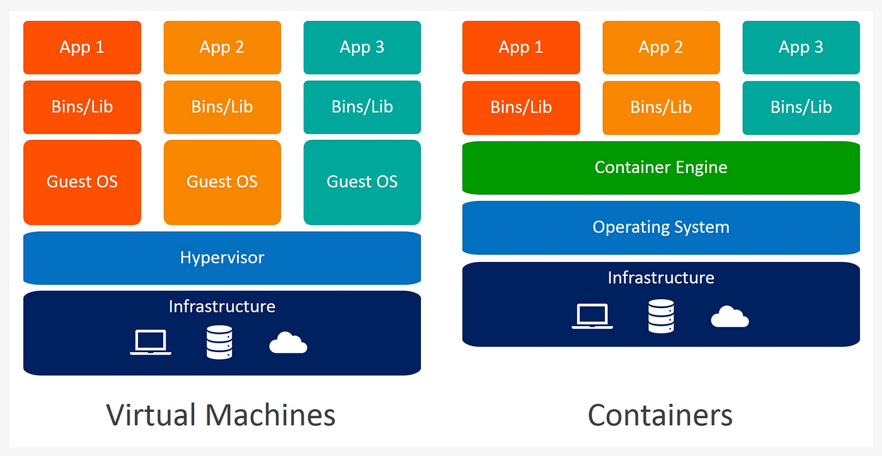

* **Server Virtualization**:
  + Uses a **hypervisor** (e.g., VMware, Hyper-V) to emulate entire physical machines.
  + Virtual machines run a full operating system with their own kernel, which leads to greater resource consumption (CPU, memory, storage).
  + Each virtual machine is isolated and can run its own independent OS.
* **Docker (Containerization)**:
  + Containers share the **host OS kernel**, which makes them more lightweight and faster than VMs.
  + Containers are isolated from each other and from the host but do not require a full OS for each instance.
  + Containers are more efficient as they use fewer resources compared to virtual machines.

**Advantages of Docker**

1. **Portability**:
   * Docker containers include everything an application needs to run, such as code, libraries, dependencies, and system tools. This ensures that the application behaves the same way across different environments (e.g., development, testing, production).
2. **Efficiency**:
   * Containers are lightweight because they share the host OS kernel. Unlike VMs, they don’t need a full operating system, which leads to better resource utilization (less disk space, CPU, and memory).
3. **Speed**:
   * Containers start much faster than virtual machines because they do not need to boot an entire OS. Starting a container is almost instantaneous, whereas VMs typically take minutes.
4. **Scalability**:
   * Docker makes it easy to scale applications. With tools like **Kubernetes** and **Docker Swarm**, you can scale containers up or down automatically based on workload requirements.
5. **Isolation**:
   * Docker ensures that each application runs in its own container with isolated dependencies. This eliminates the "works on my machine" problem and minimizes the risk of version or dependency conflicts.

**Is Docker a Virtual Machine?**

No, Docker is not a virtual machine. While both Docker and virtual machines are technologies used to isolate applications, they operate differently:

* **Virtual machines** run their own OS, including a separate kernel, which adds overhead (resource consumption).
* **Docker containers** share the host OS kernel and are isolated at the application layer, making them lightweight and efficient.

**How Does Docker Help Developers?**

* **Environment Consistency**: Developers can create a Docker container that includes all necessary dependencies, ensuring the application runs the same way regardless of the environment.
* **Simplified Setup**: Developers don’t need to manually configure environments on each system. Docker automates environment setup, reducing manual work.
* **Portability**: Docker allows developers to build and ship applications in a container that can run anywhere (developer’s laptop, testing server, cloud).
* **Faster Development**: Docker allows for quick setup of development environments, reducing friction and enabling a smoother development process.

**Why Use Docker as a Developer?**

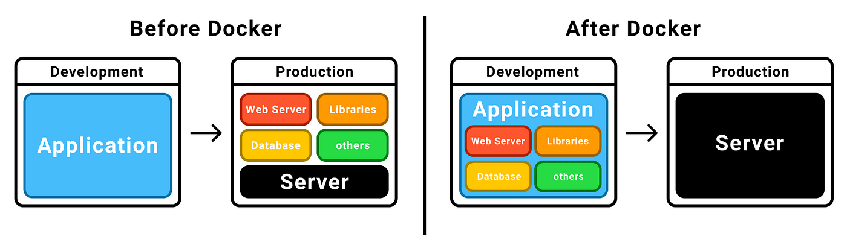

* **Faster Deployment**: Docker simplifies and accelerates the deployment pipeline by allowing developers to package applications in containers. Continuous integration and continuous deployment (CI/CD) processes can be streamlined.
* **Microservices-Friendly**: Developers can split monolithic applications into small, independently deployable microservices, each running in its own container. This makes the application more modular and easier to scale.
* **Cross-Platform Compatibility**: Docker eliminates issues where an application works on one machine but fails on another due to environmental differences.

**Docker Uses Containers**

Docker containers encapsulate everything an application needs to run: the code, runtime, system tools, libraries, and dependencies. Containers provide an isolated, consistent environment for the application, making them ideal for testing, development, and production use.

**Development Burdens**

Without Docker:

* Developers face challenges such as **dependency management**, environment setup, and **configuration issues** (e.g., different versions of libraries or tools).

With Docker:

* **Environment consistency** ensures that what works in development will work in staging and production.
* **Simplified debugging and troubleshooting**, as developers can recreate production-like environments locally using Docker containers.

**Operational Burdens**

Without Docker:

* Operations teams must ensure that applications run the same way across different environments (development, staging, production). This often involves manually installing dependencies and debugging environment issues.

With Docker:

* **Simplified deployment** means that operations teams can deploy containers without worrying about underlying infrastructure inconsistencies.
* **Scalability** is easily handled by orchestrating containers to meet demand using tools like Kubernetes.

**Why Organizations Embrace Docker Containers**

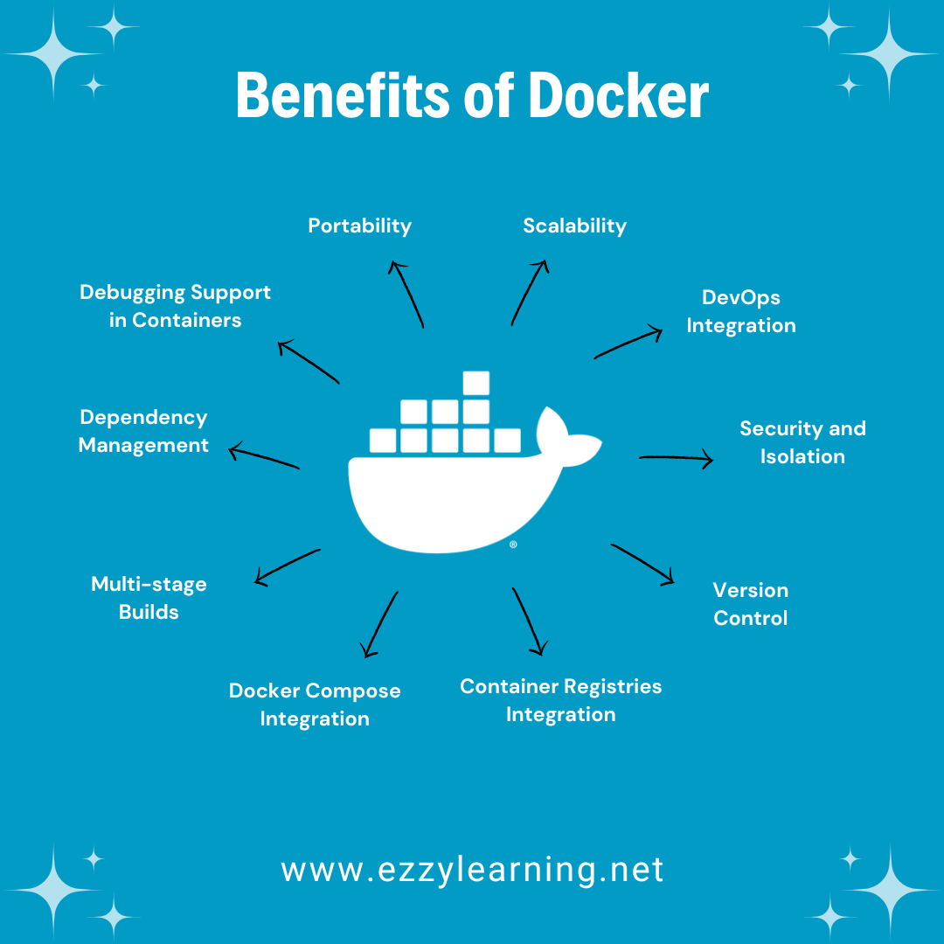

* **Cost Savings**: Docker’s lightweight nature reduces the infrastructure overhead, as multiple containers can run on the same host machine, utilizing resources efficiently.
* **Faster Development and Delivery**: Docker enables quicker testing, integration, and deployment cycles. As a result, applications can be brought to market faster.
* **Flexibility**: Organizations can run applications across different environments, whether on-premises or in the cloud, without compatibility issues.

**Container-Driven Workloads**

Containerized applications are more flexible and resilient than traditional monolithic applications. With containers, organizations can run microservices in isolation and scale them independently based on demand. This is increasingly important for handling workloads in modern cloud-native architecture.

**Substitutes for Hypervisors**

Docker containers do not require a hypervisor. Hypervisors are used for virtual machines, but Docker’s containerization technology runs directly on the host operating system. Containers are generally lightweight, faster, and easier to manage compared to VMs.

**Utilizing Microservices**

Docker is perfectly suited for deploying **microservices** because:

* Each microservice can run in its own isolated container, reducing the complexity of managing the application.
* Microservices can be developed, deployed, and scaled independently, which enhances agility and flexibility in development.

**Virtualization and Containerization Compared**

* **Virtualization** involves creating multiple virtual machines with separate operating systems and resources. VMs are more resource intensive.
* **Containerization** uses the same OS kernel for multiple containers, making it lightweight and efficient, with faster startup times.

**Convergence of Containerization and Virtualization**

While containers and VMs were initially distinct, modern solutions like **VMware Tanzu** or **Kubernetes** allow the two to coexist. VMs provide hardware isolation, while containers offer application-level isolation. Combining the two allows organizations to take advantage of both approaches.

**Containerization Innovations**

* **Kubernetes**: An orchestration tool that automates the deployment, scaling, and management of containerized applications.
* **Container Security**: New tools and approaches are continually evolving to ensure the security of containerized applications, such as image scanning, runtime security, and network isolation.
* **Networking**: Enhanced container networking models (e.g., overlay networks) allow containers to communicate securely across multiple hosts.

**Overview of Docker Editions**

* **Docker Community Edition (CE)**: Open-source, free, and designed for developers and small teams. Includes core Docker features and the Docker CLI for managing containers and images.
* **Docker Enterprise Edition (EE)**: A paid version designed for large-scale enterprise environments, offering enhanced security, support, and management tools, along with integration into enterprise IT systems.

**Installation of the Docker Engine**

The Docker Engine is the core part of Docker that runs containers. It can be installed on various platforms such as Linux, Windows, and macOS. Once installed, the Docker Daemon runs in the background, managing containers, images, and networks.

**Docker Community**

The Docker Community is a global network of developers, operators, and enthusiasts who share Docker-related knowledge, contribute to open-source projects, and collaborate on Docker initiatives.

**Docker Community Edition vs Docker Enterprise Edition**

* **Community Edition (CE)**: Ideal for developers and small teams, offering basic functionality for building and running containers. It's open-source and free.
* **Enterprise Edition (EE)**: A commercial product with advanced features like integrated security, management tools, and official support. It’s designed for large organizations with enterprise-grade requirements.

**BuildKit Features**

**BuildKit** is an advanced Docker build subsystem that improves the performance of building Docker images. It supports features like parallel builds, caching, and more efficient multi-stage builds.

**Docker Compose**

**Docker Compose** is a tool used to define and manage multi-container applications. It allows developers to specify all the services needed in a single configuration file (typically docker-compose.yml) and then deploy and manage those services together.

**Container**

A **container** is an isolated, lightweight, and executable package that contains an application and all of its dependencies (e.g., code, libraries, environment variables).

**Docker Example**

A Docker example could involve creating a **Dockerfile**, which contains instructions for building a Docker image. Once the image is built, it can be used to run containers. For example, you can create a web server container using an official Nginx image.

**Size: Let’s Understand Docker**

Containers are smaller in size compared to VMs because they don’t include an entire OS. This reduces storage requirements and accelerates the download, start, and stop operations.

**Docker Startup**

When Docker starts:

* The **Docker daemon** initializes and begins managing containers.
* The **Docker CLI** allows users to interact with Docker and issue commands.
* Containers are started based on user-defined instructions (e.g., docker run).

**Docker and DevOps Tools**

Docker is integral to DevOps practices because it automates and accelerates the CI/CD pipeline. It integrates well with tools like Jenkins, GitLab CI, and Kubernetes to automate application testing, integration, and deployment.

**Docker Architecture**

Docker's architecture includes:

* **Docker Client**: The interface through which users interact with Docker (CLI, Docker Desktop).
* **Docker Daemon**: Manages containers, images, networks, and storage.
* **Docker Registry**: A repository for storing Docker images (e.g., Docker Hub).
* **Docker Containers**: The isolated environments where applications run.

**Docker Host**

A **Docker Host** is a physical or virtual machine where the Docker Daemon runs and containers are executed.

**Understanding Microservices**

Microservices is an architecture style where applications are composed of loosely coupled services. Each service can be developed, deployed, and scaled independently. Docker’s containerization simplifies the management of microservices.

**Microservices Architecture**

In a **Microservices Architecture**, each service is:

* **Independently deployable**.
* **Focused on a single business function**.
* Often runs in a separate Docker container, allowing each service to be updated and scaled independently.

**Docker Components Overview**

Docker components include:

* **Docker Daemon**: Manages containers.
* **Docker CLI**: Command-line tool to interact with the daemon.
* **Docker Images**: Read-only templates for containers.
* **Docker Containers**: Running instances of images.
* **Docker Hub/Registry**: Store and manage Docker images.

**Docker Empowers**

Docker empowers developers, IT operations, and organizations by providing:

* **Consistency** across development, testing, and production environments.
* **Efficiency** with lightweight containers.
* **Scalability** to meet changing demands.
* **Speed** in building, testing, and deploying applications.

**Slide 5: Bridge Network**

* **Title:** Bridge Network Explained
* **Content:**
  + Default network for containers on a single Docker host.
  + Containers on the bridge network can communicate with each other by IP address.
  + Example: docker run -d --name my_container --network bridge my_image
  + **Use case:** Container-to-container communication on a single host.

**Slide 6: Host Network**

* **Title:** Host Network Explained
* **Content:**
  + Containers share the network namespace of the host.
  + No network isolation, container ports are bound to host ports.
  + Example: docker run -d --name my_container --network host my_image
  + **Use case:** High-performance scenarios or when you need to use the host's network stack directly.

**Slide 7: Overlay Network**

* **Title:** Overlay Network Explained
* **Content:**
  + Used in multi-host networking (e.g., Docker Swarm, Kubernetes).
  + Allows containers on different hosts to communicate over a virtual network.
  + Built on top of existing host networks (requires a key-value store like Consul, etcd, or Zookeeper).
  + Example: docker network create --driver overlay my_overlay_network
  + **Use case:** Multi-host container communication.

**Slide 8: None Network**

* **Title:** None Network Explained
* **Content:**
  + The container has no network interface.
  + Useful for security or for containers that do not require network access.
  + Example: docker run -d --name my_container --network none my_image
  + **Use case:** Isolation of containers, preventing external or internal communication.

**Slide 9: Docker Network Drivers**

* **Title:** Network Drivers in Docker
* **Content:**
  + **Bridge Driver:** Default for standalone containers.
  + **Host Driver:** Containers share the host's network stack.
  + **Overlay Driver:** For multi-host networks.
  + **Macvlan Driver:** Allows containers to have their own MAC address and appear as physical devices.
  + **None Driver:** No networking.

**Slide 10: Exposing Ports in Docker**

* **Title:** Exposing Container Ports
* **Content:**
  + Containers have their own internal ports.
  + To access a container from outside, you must map the container's ports to the host.
  + Example: docker run -d -p 8080:80 my_image
  + **Explanation:** Maps port 8080 on the host to port 80 on the container.

**Slide 11: Docker Networking Commands**

* **Title:** Docker Networking Commands
* **Content:**
  + docker network ls: List available networks.
  + docker network inspect <network_name>: Inspect a network’s configuration.
  + docker network create <network_name>: Create a new custom network.
  + docker network connect <network_name> <container_name>: Connect a container to a network.
  + docker network disconnect <network_name> <container_name>: Disconnect a container from a network.

**Slide 12: DNS in Docker Networking**

* **Title:** DNS Resolution in Docker
* **Content:**
  + Docker provides a built-in DNS service for container name resolution.
  + Containers can resolve each other by name within the same network.
  + Example: If a container is named web, you can reach it from another container using web:port.

**Slide 13: Docker Compose Networking**

* **Title:** Networking with Docker Compose
* **Content:**
  + Docker Compose simplifies multi-container Docker applications.
  + Containers defined in a docker-compose.yml file can communicate by default via a shared network.
  + Example:

yaml

Copy

version: '3'

services:

web:

image: nginx

db:

image: mysql

* + **Note:** Both containers (web and db) can communicate over the default network.

**Slide 14: Security Considerations**

* **Title:** Security and Docker Networking
* **Content:**
  + Containers should be isolated using proper network segmentation.
  + **Docker network policies** allow defining rules for inter-container communication.
  + Use **Overlay Networks** for secure communication in multi-host setups.
  + Regularly audit network access with tools like **Docker Security Scanning**.

**Slide 15: Troubleshooting Docker Networking**

* **Title:** Troubleshooting Docker Networks
* **Content:**
  + **Check connectivity**: docker exec -it <container_name> ping <other_container>
  + **Inspect network details**: docker network inspect <network_name>
  + **Logs**: docker logs <container_name> for network-related issues.
  + Use **Docker logs** and **network inspect commands** to debug and resolve issues.

**Slide 16: Summary**

* **Title:** Key Takeaways
* **Content:**
  + Docker networking allows containers to communicate using various network modes (Bridge, Host, Overlay, None).
  + You can expose container ports to the host using -p.
  + Custom networks in Docker Compose make it easier to manage multi-container setups.
  + Security and proper isolation are crucial in a production environment.
  + Docker networking is flexible, and you can adapt it based on your application’s needs.

**Slide 17: Q&A**

* **Title:** Questions & Answers
* **Content:** Open the floor for questions and clarifications.
* **Image:** Optional, could be a relevant Docker or networking-related graphic.